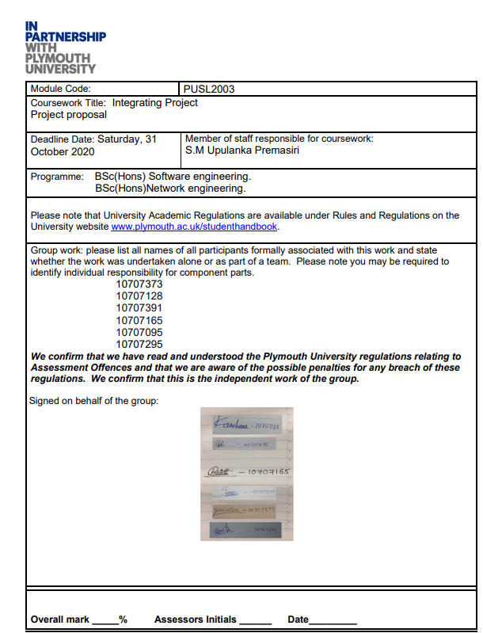



**PUSL2003 Integrating Project**

**Project Proposal 2020/21**

**Smart Car Parking System With IOT**

Group Name: **No  54** .

Members:

|  |  |  |
| --- | --- | --- |
| ID | Name | Degree Program (SE/CN/CS) |
| 10707373 | S.K.Y Silva | SE |
| 10707128 | R.G.K.D Amarasooriya | SE |
| 10707391 | H.W.N Thathsara | SE |
| 10707165 | P.N De Silva | SE |
| 10707095 | G.M.S Lakshan | CN |
| 10707295 | R.D Paranawithana | SE |

**Introduction**

In this era, in order to manage 24 hours of a day, most of the people have their own vehicle. But due to this huge number of vehicles, nowadays it’s hard to find a place park in cities, specially during this peak time.

We decided to propose a solution for this issue. It is an automated parking system. Through an automated parking system, we can book our own spot using few steps of clicking and tapping. The main thing is a person can reserve a place by paying through internet. Then he can park his vehicle in the reserved place on the booked date. For the main gate of the parking area, we use image processing to capture the number of plates of the driver and these captured details will be stored in a database. If a person needs to book a place through internet, he/she must register using mobile application by giving basic information about user. After that process, driver can select a place as his wish. The server then immediately processes the received data and returns the necessary information to the user.

As soon as the driver allocates space, the server Generates a unique QR code and sends it back to the user. After the QR code, send it to the user when it should be later and let the user use a sustainable setting. This QR code stores details such as parking fees, availability and provides references..

Beside reservation, uses also can find out Parking details, such as connecting or paying via text message.. There are sensors to detect all the details inside the parking area.

**Objectives**

In manual parking system, there we have to drive our vehicle all around the park to find a space. That is a waste of time. Through the mobile application drivers can easily search available parking slots. Also, user can view the duration of parking use through this mobile application and calculate costs.

We can guarantee the security of the vehicles because we use image processing to capture the number plate of the drivers and we store them in a database to avoid theft and illegal car entry.

Sometime after reaching the parking area, we get to know that there is no space to park. It also a waste of time. To avoid this this situation, we can check the available spaces in the park through the application. In that kind of a situation, we can book our space early through the app and without any trouble or wasting time, person can park his vehicle without any delay.

We issue a unique QR code to avoid conflict situations. As an example, sometimes we reserved our slot early but before we enter the parking area someone entered there and park his vehicle already. In such situation no point of arguing, because already we waste our time and, we are in trouble. Through this method we can ensure that, after getting this QR code no one can park his car in this reserved area except the reserved person.

## **Background & Motivation**

***“Colombo needed better parking and more management as the city continued to ease traffic congestion.***..

According to the Ministry of Transport and Civil Aviation, the number of vehicles in Sri Lanka in 2017 was 7,247,122, compared to 6,795,469 in 2016. More than 500,000 vehicles are said to enter Colombo daily, and the city has a severe shortage of parking for most of these vehicles.

This is a paper article which belongs to one of very famous newspaper “SUNDAY OBSERVER”. They clearly mentioned issues in Colombo city due to this vehicle population. This issue is not limited only to Colombo. In 2020, we can see this issue in every city of Sri Lanka. When there is no space to park, most people park their vehicles on a side of the main road. Because of that there is not enough space to drive vehicles in the city and therefore there can be a huge traffic. Then what we can do...? Can we stop buying vehicles to decrease vehicle population…?

***“There is a lot of talk about traffic in Colombo with the inevitable traffic congestion resulting in lower speeds, longer travel times and more traffic lines. The economic loss of the driver and the city is enormous; the passenger has to spend time with the fuel he wants to park, and the city may not make full use of its assets i.e. public roads. “***

“Traffic” We heard this word usually. Where we can see the traffic...? usually we can see this in the cities, because most people go for working to the cities. What will happen if they are late. We all know that if there is a bit of delay, there are tons of complains against you. Even it can be affected to your salary as well. Traffic is a major reason for the delay of our daily life. Due to the vehicle population, we have to face this kind of situations. Traffic is there, when there is not any proper parking management in the city. We can’t do this manually. Then what we need know...?

***“Complaint of the robbery of a vehicle received by the Police, the Accused was arrested, and the disputed vehicle was also taken into custody by the Accused and produced before the Magistrate Court.”***

Robbery cases are another issue that we should focus. When we are out of our house, anyhow how we have to park our vehicle somewhere. After we are moving out from that place, we do not have any idea whether it is there or not until we come there. That means we cannot assure the security of the vehicle. There can be a robbery or accident anyhow we must bear the expense and waist our time. We can’t come there twice a hour and check whether it is okay or not. Is this a solution...?

For all the mentioned issues, there is a solution. It is just a simple solution but hard to implement. It’ll be a advantage and a solution if we manage to implement this automated parking system somehow.

• We can avoid wasting time

• Assure the security

• Manage the traffic

## **Approach & Methodology**

We think that this is best solution for the current situation in sri Lanka and, we can implement this to the world. As an example,

In Sri Lanka there are lot of parking areas. But the problem is it is hard to make a space when we needed. In some situations, we must face some accidents due to the lack of proper management of the parking area. In a parking area there is a security person or someone to take care of them and guide the drivers into the parking area. But this is not 100% successful method, because still there can be theft or something illegal problem.

These are the issues that we all have. Through this automated parking system, we can sort all the mentioned issues. When we focus on the theft issues, it can be handled through image processing sensors. As I mentioned before, we store all these in a database to avoid such issues. In the other hand there are sensors to monitor the behaviors of every vehicle. No one can do anything illegal due to these strict security systems.

Vehicle owner always require avoiding accidents which can damage their vehicle in a parking area. This is a common issue. But unfortunately, such situation can be occurred when we park our vehicle and when we try to come out of the park. To avoid these issues monitoring sensors,360 cameras are installed in the parking area.

In addition to this issue, there is another issue called performance issues. These are articles about insurance, heating, ventilation, electricity and staff. Insurance premiums have been proven to fall by almost 50 to 70 percent thanks to driver reduction caused by accidents and the elimination of cracks. Heating is not necessary because there are no people in the garage. Because there are no engines running in the garage, emissions are reduced, and the air must be changed every hour. Power outages due to the lack of regular lighting and the fact that there are no elevators that have to work in the garage.

## **Resource Requirement**

***Software Requirements***

* Open CV
* TensorFlow Library- OCR PART
* Azure/Google Cloud.
* Android Studio
* Eclipse / Visual Studio - JAVA SE/ JAVA EE /C#
* PyCharm- Python for Image processing System .
* Firebase OTP and Google API

***Hardware Requirements***

* Camera – LPR License Plate Recognition Capture 2.0
* Ultrasonic sensor
* Micro Radar/ Magnetic sensor
* Monitor-2 (One Touch Screen Display)
* CPU -RAM 4 GB
* 360 cameras - Hikvison 2MP 8Ch DVR
* Alarm-Quick Sens (Qs-H3) 220v-11DB
* Automatic gate barrier / Arduino

**Budget**

|  |  |
| --- | --- |
| **Name** | **Price** |
| 1. Cloud Storage | $300 |
| 1. Images | $30 |
| 1. LPR (Camera) | $168 |
| 1. Hikvison 2MP 8Ch DVR Camera | $500 |
| 5. Automatic gate barrier | $350 |
| 6. other(CPU, Monitor, Sensor) | $400 |

## **Project Pl****an**

Start day – Oct/17 /2020.

End day - Jan/ 15 /2021.

Mobile Application

Test /and Final Configuration

Idea

Desktop

application

feasibility study/analysis

Hardware Development (IOT)

# **Bibliography**

[1]. Retrieved from https://www.youtube.com/watch?v=s-7on9BO-Po

[2]. Retrieved from https://www.youtube.com/watch?v=VWGFr7g0qxU

[3]. Retrieved from https://www.youtube.com/watch?v=s-7on9BO-Po

[4]. Retrieved from https://medium.com/@jeremymartin071/advantages-and-disadvantages-of-automated-parking-system-d725492fd67f

[5].http://www.ft.lk/Opinion-and-Issues/Managed-parking-has-potential-to-transform-Colombo-s-increasingly-congested-streets/14-674609

[6].<https://www.sundayobserver.lk/2018/07/15/news-features/colombo-needs-better-managed-parking>

[7]. <http://webcache.googleusercontent.com/search?q=cache:mCr-CTiqKX0J:courtofappeal.lk/index.php%3Foption%3Dcom_phocadownload%26view%3Dcategory%26download%3D3982:ca-phc-1492009-liyana-arachchige-ivan-gamini-de-silva-vs-hon-attorney-general-hon-ltb-dehideniya->j%26id%3D71:november%26Itemid%3D128+&cd=1&hl=en&ct=clnk&gl=lk&client=opera

**Thank you!**